10.23:

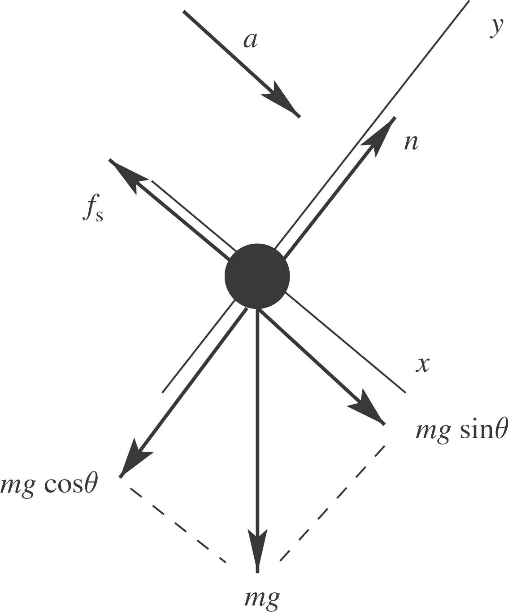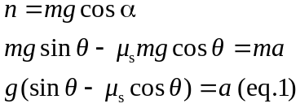
and 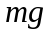act at the center of the ball and provide no torque.
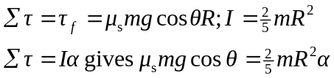
No slipping means 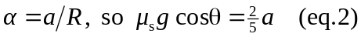
We have two equations in the two unknowns a and 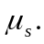 Solving gives
b) Repeat the calculation of part (a), but now 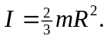

The value of 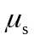 calculated in part (a) is not large enough to prevent slipping for the hollow ball.

c) There is no slipping at the point of contact.

